

Programme Name: **BCS**

Course Code: **CSC 1013**

Course Name: **System Analysis and Design**

Assignment **: First**

Date of Submission**: 5/2/2020**

**Submitted By: Submitted To:**

Student Name: **Dipesh Tha Shrestha** Name: **YOGENDRA BAHADUR MAHATA**

Semester: **second**

Intake:**2019**

1. Define the system.

=A System is a collection of elements or components that are organized for a common purpose.

A System is a way of working, organizing, or doing something which follows a fixed plan or set of rules.

1. Elaborate concepts of System, Information System and Computer Information Systems.
   1. System – Solar System, Government Rules etc
   2. Information System – Newspapers, Media, can be paper based also
   3. Computer Information System – Software and accessories

Answer:

1. System: A set of things working together as parts of a mechanism or an interconnecting network; a complex whole is also known as system. For example: Solar system is system in which every planets, star, asteroid, meteoroids etc. work as whole.
2. Information System: Information systems are combinations of hardware, software, and telecommunications networks that people build and use to collect, create, and distribute useful data, typically in organizational settings.
3. Computer information systems is the application of technology in managing the needs of businesses, so you’ll get to put your technical skills to work in a business setting. Students in the computer information Systems major learn how to work with companies’ IT systems to solve operations issues.
4. List at least three people at your school or a nearby company who use information systems. List the systems, the position titles of the users, and the business functions that the systems support. [Hint: Banks, ISPs, Restaurants, Departmental Stores]

|  |  |  |  |  |
| --- | --- | --- | --- | --- |
| Name | Organization | Work /Position | System | function |
| Bishnu kapkota | Supreme Academy Higher Secondary School | D.I | Analog Security System | Check the student behaviors and staff behavior. |
| Shyam Shrestha | The Water Solution | Accountant | Fin Pro | Record the financial transaction of the company. |
| Royal Shrestha | Big market | Customer Service Representative | IMS POS Software | Answer all customer inquiries whether it’s a concern, product question , or even a negative review |

= The list of systems, the position titles of the users, and the business functions that the systems support is given below:

1. Discuss in detail about software currently used in Nepal (say, Banks using Globus, T24, Pumori, Mobile Applications such as Khalti).

* **eSewa**

Nepal’s first online payment gateway is a comprehensive online payment solution. With eSewa digital wallet, customers can pay, send and receive money simply using their mobile phone and the Internet instantly. eSewa have been operation since 2009 and have been licensed by Nepal Rastra Bank as Payment Service Provider.

Customers can use eSewa web/mobile application for mobile recharge, electricity bill payment, TV payment, Online travel ticketing, Online shopping, movies ticketing, school/ college fee payment, credit card payment, insurance premium and many more. Similarly, merchants, service providers and retail outlets can receive payments for goods and n

eSewa App is available for both iOS and Android devices and its primary web portal is [www.esewa.com.np](http://www.esewa.com.np/)

* **T24**

**T24** is the most technically advanced banking system in the world today. It is a 24-hour real-time banking application that provides multiple application server support to a huge number of users. The system also eliminates the need to run End Of Day processing. T24 is an integrated core banking solution that is often referred to as “all in one” technology resource. T24 equips financial institutions with all the necessary tools for managing the entire workflow of banking operations from both back and front end in addition to client relationship management. T24 has established strong reputation in financial services market over the past 14 years

* **Pumori**

Pumori banking software is an innovative and reliable software platform designed to build centralize solutions for banks, financial institutions and co-operative sectors. The banking software developer group of Mercantile Office Systems (MOS) created Pumori Banking Software which is a complete banking software solution based on a Microsoft platform (Windows) and Microsoft SQL Server.

* **Globus**

Globus is a software with components and capabilities that includes: A set of service Implementations that Indicate resource management, data alterations service finding and relevant issues. Tools for building web services. A powerful standards-based security prerequisites for authentication and authorisation.

1. Draw the keyboard and explain the shortcut keys used in your daily life.

=The shortcut keys used in daily life are given below:

|  |  |
| --- | --- |
| Shortcut key | Uses and function |
| Ctrl+Z | To reverse your last action, press **CTRL**+**Z**. You can reverse more than one action. |
| Ctrl+X | **Ctrl**+**X** is a **shortcut key** most often used to cut any selected text, image, or other objects. |
| Ctrl+C | **Ctrl**+**C** is a **shortcut key** most often used to copy any selected text, image, or other objects. |
| Ctrl+V | **Ctrl**+**V** is a shortcut key most often used to paste text or other objects from the clipboard |
| Ctrl+A | **Ctrl+A** is a shortcut key most often used to select all text, or other objects while in a graphical user environment. |
| Ctrl +S | **Ctrl+S** is a shortcut key most often used to save the file and document. |

=the diagram of keyboard is given below: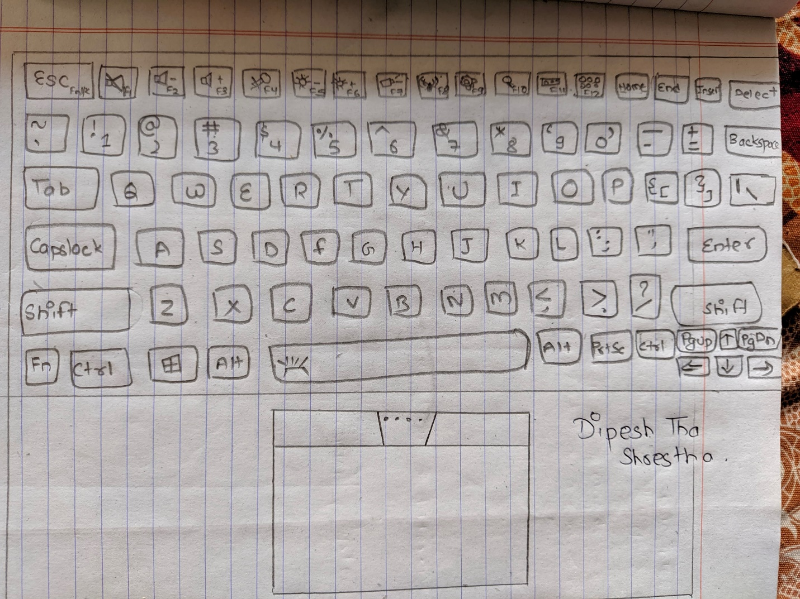

1. List down the ISP ( Internet services Provider) Currently available in Nepal.

=The ISP currently available in Nepal are:

* Vianet

Vianet was established in 1999 in Nepal. As it uses Optical Fiber technology, it stands out from rest. It provides a wide range of internet package including both limited and unlimited internet access.With the growing number of internet users, the need for flexible, quality and cost-effective internet plans is also growing. Keeping these things in mind, Vianet has been providing a stable connection with high-quality internet service to the customers.

* Worldlink

Worldlink which claims to be the largest ISP in Nepal offers FTTH service at a wide range of speed and data package. They serve internet to home, business, and enterprise, and have a good coverage. If you are a home user you may want to stick with Fiber-Home service.

* Subisu

Subisu was one of the best ISPs in Nepal a while back. However, now, users are rating it down. It attracted users because of its speed, reliability & services. It seems to have gone in the opposite direction, though. A lot of users are complaining about its slower speed, long downtime, and other problems.

* Classic Tech

Classic Tech is the best wireless Internet Service Provider in Nepal. It also provides internet via fiber. Classic Tech is used by some well-known Nepali offices like Nepal Police headquarters, NPL, NAC, etc, and are trusted by them. They provide good customer care and a lot of people suggest Classic Tech.

1. Define System Analyst.

=A systems analyst is an information technology professional who specializes in analyzing, designing and implementing information systems.

A systems analyst is a person who uses analysis and design techniques to solve business problems using information technology. Systems analysts may serve as change agents who identify the organizational improvements needed, design systems to implement those changes, and train and motivate others to use the systems.

1. Differentiate System Analyst and Business Analyst  .

|  |  |
| --- | --- |
| **System Analyst** | **Business Analyst** |
| * focus on system specific requirements. | * focuses on the broader context in the business of business changes and systems development for a business. |
| * Based on IT department. | * Bridge between IT and Business |
| * Evaluate technical solution | * Develops the Business Case |
| * Resource efficiencies | * Stakeholder focused |
| * System Testing | * User Acceptance Testing |
| * Good written and mathematical/analytical skills | * Excellent communication skills |
| * Systems focused(IT) | * Application focused(IS) |

1. Define the steps of SDLC.

=The steps of SDLC are:

* Requirement gathering and analysis

During this phase, all the relevant information is collected from the customer to develop a product as per their expectation. Any ambiguities must be resolved in this phase only.

Business analyst and Project Manager set up a meeting with the customer to gather all the information like what the customer wants to build, who will be the end-user, what is the purpose of the product. Before building a product a core understanding or knowledge of the product is very important.

* Design

In this phase, the requirement gathered in the SRS document is used as an input and software architecture that is used for implementing system development is derived.

* Implementation or coding

Implementation/Coding starts once the developer gets the Design document. The Software design is translated into source code. All the components of the software are implemented in this phase.

* Testing

Testing starts once the coding is complete and the modules are released for testing. In this phase, the developed software is tested thoroughly and any defects found are assigned to developers to get them fixed.

Retesting, regression testing is done until the point at which the software is as per the customer’s expectation. Testers refer SRS document to make sure that the software is as per the customer’s standard.

* Deployment

Once the product is tested, it is deployed in the production environment or first UAT (User Acceptance testing)  is done depending on the customer expectation.

In the case of UAT, a replica of the production environment is created and the customer along with the developers does the testing. If the customer finds the application as expected, then sign off is provided by the customer to go live.

* Maintenance

After the deployment of a product on the production environment, maintenance of the product i.e. if any issue comes up and needs to be fixed or any enhancement is to be done is taken care by the developers.

1. Define Prototype

=A prototype is an early sample, model, or release of a product built to test a concept or process. A prototype is the original model, a sample on which to base future designs.

1. Draw  any system diagram and label it.

=Any system diagram is given below:

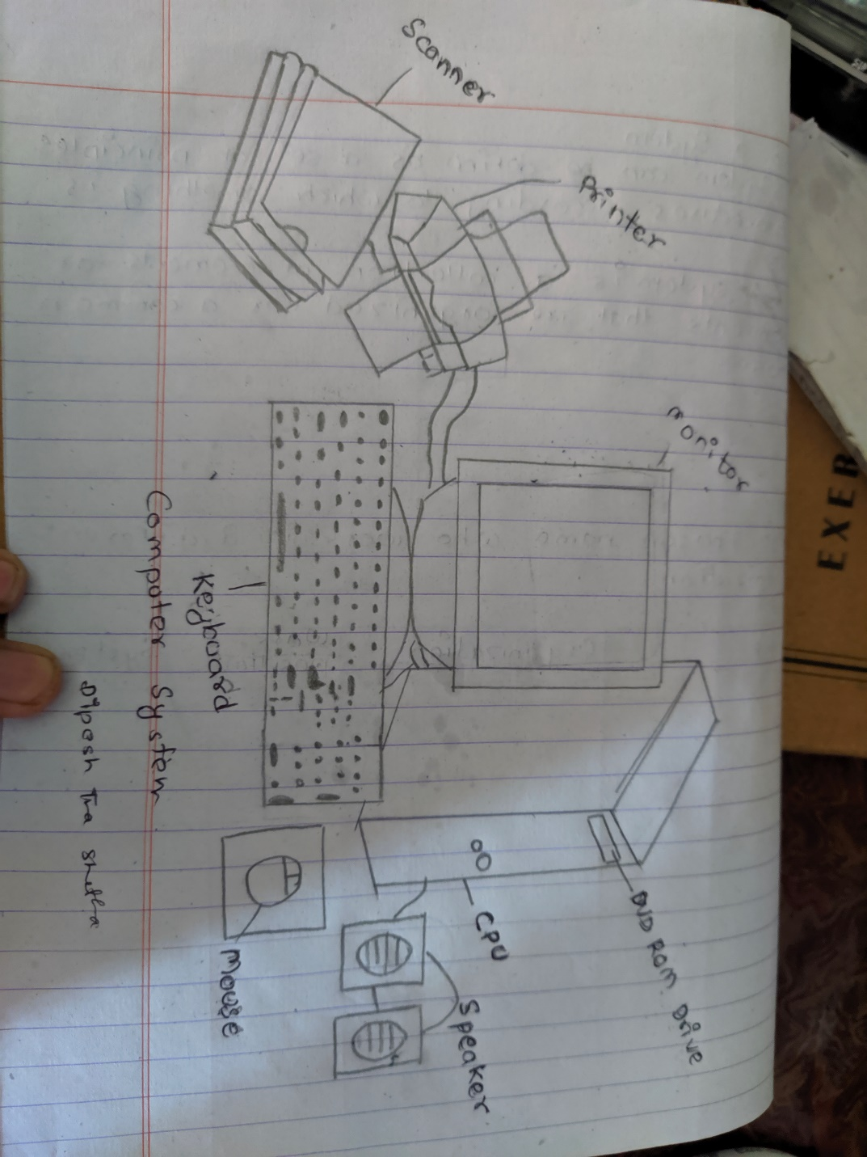

1. **Why do system analyst need to know who the stakeholders are in the organizations**?

= The systems analysts need to know who the stakeholders are in the organization because the system analyst servers as a facilitator or a couch, bridging the communications gap that an naturally develop between the nontechnical system owners and users and technical system designers and buildings. As we can see the system analyst plays a key role in bringing all these users to understand, therefore the system analyst need to know each and every one of the stakeholders to characterize how he or she will approach each stakeholder.

1. **Define system development methodology.**

= A system development methodology refers to the steps that are used to form, plan, and control the process of developing an information system since it is virtually impossible to drive forward a project to computerize method without prior work. A wide variety of such frameworks have evolved over the years, each with its own recognized strengths and weaknesses.

1. **what kind of knowledge and skills should a system analyst posses.**

=The knowledge and skills that a system analyst should posses are given below:

* **Analytical**

At the beginning of a project, a systems analyst has to understand the requirements of the client and study the various ways in which the requirements can be met. Once the various ways are found out, the onus is on the systems analyst to thoroughly analyze the pros and cons of every solution before deciding on a best feasible solution. The system analyst also has to analyze the ways and means of applying a solution which has been zeroed upon.

* **Efficient Planning and Execution**

A systems analyst is expected to have a keen eye for detail and has to plan the various stages in which the project has to be executed. He/she has to come up with a skeleton plan of how the product would look like and has to chalk out the deliverables. After defining the plan, he/she has to ensure that all the details of the plan are adhered to and the different stages are executed perfectly.

* **Technical Knowledge**

A systems analyst must have sample technical skills because they have to help the technical team design a product which is to suit the customer’s needs. He/She must have a working knowledge of the prevalent operating systems, programming languages and hardware platforms. A systems analyst is expected to help in coding and debugging of a customized product. Further, he/she should also be able to tweak up the initial design based on the customer’s feedback. The systems analyst is expected to constantly help in redesigning till the end product has been delivered to the client and has got the approval.

* **Man Management**

Any systems analyst has to have great interpersonal skills and the ability to manage people. He/she has to coordinate with the different technical teams and get the product customized as per requirement delivered within the deadline agreed upon. The systems analyst should ensure that no feathers have been ruffled and the whole team functions smoothly.

1. **what are the difference between internal user and external user? Give example**

**=**The difference between Internal User anf External User is given below:

|  |  |
| --- | --- |
| **Internal User** | **External User** |
| * Internal users refer to the members of a company's management and other individuals who use financial information in running and managing the business. | * External users are entities or individuals who do not participate in running or managing the business but are interested in the financial information of the company |
| * Internal users are owners, directors, managers, employees of the company. | * External users are creditors, investors, government, trading partners, regulatory agencies, international standardization agencies, journalists. |
| * Internal users are that individual who runs, manages and operates the daily activities of the inside area of an organization. | * External users are those individuals who take interest in the account information of an organization but they are not part of the organization’s administrative process. |
| * Internal users are people within a business organization who use financial information | * External users are people outside the business entity (organization) who use accounting information. |
| * **Examples of internal users** are owners, managers, and employees. | * **Examples of external users** are suppliers, banks, customers, investors, potential investors, and tax authorities |

1. **Explain THREE(3) elements involve in designing a system.**

=The Elements involve in designing a system are:

* **Outputs and Inputs**

A major objective of a system is to produce an output that has value to its user. Whatever the nature of the output (goods, services, or information), it must be in line with the expectations of the intended user. Inputs are the elements (material, human resources, and information) that enter the system for processing. Output is the outcome of processing. A system feeds on input to produce output in much the same way that a business brings in human, financial, and material resources to produce goods and services. It is important to point out here that determining the output is a first step in specifying the nature, amount, and regularity of the input needed to operate a system. For example, in systems analysis, the first concern is to determine the user’s requirements of a proposed computer system – that is, specification of the output that the computer is expected to provide for meeting user requirements.

* **Processors**

The processor is the element of a system that involves the actual transformation of input into output. It is the operational component of a system. Processors may modify the input totally or partially, depending on the specifications of the output. This means that as the output specifications change so does the processing. In some cases, input is also modified to enable the processor to handle the transformation.

* **Control**

The control element guides the system. It is the decision – making subsystem that controls the pattern of activities governing input, processing, and output. In an organizational context, management as a decision – making body controls the inflow, handling and outflow of activities that affect the welfare of the business. In a computer system, the operating system and accompanying software influence the behaviour of the system. Output specifications determine what and how much input is needed to keep the system in balance. In systems analysis, knowing the attitudes of the individual who controls the area for which a computer is being considered can make a difference between the success and failure of the installation. Management support is required for securing control and supporting the objective of the proposed change.

1. **Differentiate between data and information**

=The differentiate between data and information is given below:

|  |  |  |
| --- | --- | --- |
|  | **Data** | **Information** |
| Definition | Data is raw, unorganized facts that need to be processed. Data can be something simple and seemingly random and useless until it is organized | When data is processed, organized, structured or presented in a given context so as to make it useful, it is called information. |
| Format | Data is in the form of numbers, letters, or a set of characters. | Ideas and inferences. |
| **Represented in** | It can be structured, tabular data, graph, data tree, etc. | Language, ideas, and thoughts based on the given data. |
| Meaning | Data does not have any specific purpose. | It carries meaning that has been assigned by interpreting data. |
| Features | Data is a single unit and is raw. It alone doesn't have any meaning. | Information is the product and group of data which jointly carry a logical meaning. |
| **Dependence** | It never depends on Information. | It depended on Data. |
| Example | Each student's test score is one piece of data. | The average score of a class or of the entire school is information that can be derived from the given data. |

1. **Define an Information System**.

=Information systems (IS) is the study of complementary networks of hardware and software that people and organizations use to collect, filter, process, create, and distribute data. Information systems are interrelated components working together to collect, process, store, and disseminate information to support decision making, coordination, control, analysis, and visualization in an organization.

1. **There are several different types of information system. List and briefly explain all types of information system with an example.**

=The list of all types of information system with an example is given below:

* **Transaction processing system**
* **Decision support system**
* **executive information system**
* **Management information system**
* **Workflow system**
* **Enterprise resource planning and Expert systems.**
* **Transaction Processing Systems (TPS)**

A **Transaction Processing Systems (TPS)** is used primarily for record keeping which is required in any organization to conduct the business. Examples of TPS are sales order entry, payroll, and shipping records etc. TPS is used for periodic report generation in a scheduled manner. TPS is also used for producing reports on demand as well as exception reports**. For example**, if a store sells items on credit and they have a credit policy that has some set limit on the borrowing. All the sales person needs to decide whether to give credit to a customer or not is based on the current credit information from the system.

* **Decision Support System (DSS)**

**Decision Support System (DSS)** serves the management of an organization. A decision support system has sophisticated data analysis tools, which support and assist all aspects of problem-specific decision-making. DSS may use data from external sources such as current stock prices to enhance decision-making. DSS is used when the problem is complex and the information needed to make the best decision is difficult to obtain and use. DSS is developed with the help of decision-makers in an organization. DSS helps in the appropriate decision-making process and does not make any decision. **Examples** of decision support systems include Financial Planning System, Bank Loan Management System.

* **Executive Information System (EIS)**

An **Executive Information System (EIS)** is also called the Executive Support System. Senior managers of an organization use the EIS. Therefore, it must be easy to use so that executives can use it without any assistance. EIS can do trend analysis, exception reporting and have drill-down capabilities. The results are usually presented in a graphical form tailored to the executive’s information needs. EIS has on-line analysis tools and they access a broad range of internal and external data.

* **Management Information Systems (MIS)**

**Management Information System (MIS)** provides the management routine summary of basic operations of the organization. The essential services are recorded by the TPS of the organization and MIS consolidates the data on sales, production etc. MIS provides routine information to managers and decision makers. The primary objective behind installing an MIS in the organization is to increase operational efficiency. MIS may support marketing, production, finance, etc. **For example**, input from a point of sale system can be used to analyze trends of products that are performing well and those that are not performing well. This information can be used to make future inventory orders i.e. increasing orders for well-performing products and reduce the orders of products that are not performing well.

* **Workflow System**

A **workflow system** is a rule-based management system that directs, coordinates and monitors the execution of an interrelated set of tasks arranged to form a business process. There are three types of workflow software. They are:

* Administrative workflow systems focus on the tracking of expense reports, travel requests, messages.
* An Ad-hoc workflow system deals with the shaping of product, sales proposals and strategic plans.
* Production workflow systems are concerned with mortgage loans and insurance claims.

A workflow system may be Internet-based and may be combined with e-mail. A workflow system may be based on server architecture that may use a database or file server. Example of Workflow System Are Employee Onboarding, New Client Setup, Product Return Authorizations, Documentation Requests etc.

.

* **Enterprise Resource Planning (ERP)**

**Enterprise Resource Planning (ERP) system** is a business process management software that allows an organization to use a system of integrated programs capable of managing a company’s vital business operations for an entire multi-site, global organization. Supply chain management and customer relationship management systems are each **examples** of enterprise resourcesystems.

* **Expert Systems**

The **expert systems** have the ability to make suggestions and act like an expert in a particular field of an organization. An expert system has an extensive knowledge base. MYCIN, DENDRAL, R1/XCON, PXDES etc are some example of Expert System.

1. **Assume you are a system analyst who will be conducting a requirements analysis for an individually owned brick-and-mortar retails store with a point-of-sale(POS) system. Identify the typical internal and external user might include**.

=If I was a system Analyst who will be conducting a requirements analysis for an individually owned brick-and-mortar retails store with a POS system, the typical internal user may be **directors, owners, managers, and employees** whereas external users may be **creditors, investors, government, trading partners, regulatory agencies, suppliers, banks, customers, and tax authorities.**

1. **Assume you are a system analyst for a consulting company and have been asked to assist the chief executive officer(CEO) of a regional bank. the bank recently implemented a plan to reduce the number of staff, including loan officers, as a strategy to maintain profitability, subsequently, the bank experienced chronic problems with backlogged loan officers who are able to review and approve or disapprove loans. The CEO of the bank is interested in solutions that would allow the approval process to move faster without increasing the number of loan officer and has engaged your company to come up with suggestions. What is one type of system that you might recommended to the bank?**

=I will recommend **Decision Support System** to the Bankbecause itsupports business or organizational decision-making activities. Decision support systems increase interaction between the manager and computer systems, and thus there won’t be a need for the manger to deal with decision support systems directly. Decision support systems’ characteristics are represented through: supporting the decision-making process, but not replacing it. It is organized by the middle and senior managements in the organization. It provides private data in all the aspects and areas that are related to the decision-making process.

DSSs include knowledge-based systems. A properly designed DSS is an interactive software-based system intended to help decision makers compile useful information from a combination of raw data, documents, and personal knowledge, or business models to identify and solve problems and make decision.

Examples of decision support systems include;

**Financial planning systems** – it enables managers to evaluate alternative ways of achieving goals. The objective is to find the optimal way of achieving the goal. For example, the net profit for a business is calculated using the formula Total Sales less (Cost of Goods + Expenses). A financial planning system will enable senior executives to ask what if questions and adjust the values for total sales, the cost of goods, etc. to see the effect of the decision and on the net profit and find the most optimal way.

**Bank loan management systems** – it is used to verify the credit of the loan applicant and predict the likelihood of the loan being recovered.

So, **Decision Support System** is the best system to reduce the number of staff, including loan officers, as a strategy to maintain profitability, subsequently, the bank experienced chronic problems with backlogged loan officers who are able to review and approve or disapprove loans.

**1- Search the Web or Business periodicals in your library such as Forbes Magazine for information on three or four Chief Information officers of Large companies or Organizations.**

1. Which industry sector, companies and CIOs did you find
   1. Ben Fried(Google)
   2. Atish Banerjea(Facebook)
   3. Niall O'Connor(Apple)
2. For each CIO that you researched, what was their predominant experience prior to becoming a CIO; that is, did they have an information technology, background, a business background, or both?
   1. Ben Fried(Google)

He did have background in information technology.

* 1. Atish Banerjea(Facebook)

He did have background in information technology.

* 1. Niall O'Connor(Apple)

He did have background in both information technology and business

1. For each CIO, What is their level of education?
2. Ben Fried(Google)

Degree in computer Science.

1. Atish Banerjea(Facebook)

Degree in computer Science.

1. Niall O'Connor(Apple)

Degree in computer Science.

1. How many years has each been a CIO, and for approximately how many different companies has each one worked?

= They have been CIO in Google , Facebook , Apple for 7 , 23 and 4 recpectively.

1. Based upon your research, what knowledge and skills does a CIO need in order to be successful? Why ?

**=** Based on my research CIO needs technological ,business and informational knowledge to be successful.

1. **what do you think will be possible technologically 10 years from now? How about 20 or 30 years from now ? Research a new and interesting technology that is in the research and development stage**

**=**Ask anybody what personal technology will look like 10 years from now, and you’ll probably get a wrong answer. A decade ago, almost nobody could predict that more than a million people would buy a watch that not only tells the time, but reads your text messages, checks the weather and tracks your workouts, too. But that’s exactly what happened.

* *Smart shoes could charge your phone’s battery while you rush to work*
* *Your shirt could vibrate to help you find your way*
* *A personal assistant could be embedded in contact lenses*
* *Intelligent earrings could find the perfect songs for your mood*

1. **Prepare a presentation using a movie clip and PowerPoint on this technology and present it on the class.**

**= I will add presentation next to it**

1. **Submit a short paper on the impacts this new technology might have on society and/or businesses**

**=** In the last few years, there has been a cultural shift (and technological) shift from wearables focused on promoting wellness to those designed to foster real-time tracking and monitoring of patient vital signs. Backed by concurrent advancements in the fields of the internet of thing (IoT) and software development, the current itinerary of wearable devices have the potential to function as an integrated electronic health record system, only this time without the inherent inefficiencies of traditional EHR systems. By current estimates, the next 25 years should see wearable technology prosper a global cost savings of about $200 billion in the health care sector. This cost savings is in part down to the increasingly accurate predictive capability of wearable technologies. It is a known fact that wearable technologies working in tandem with artificial intelligence (AI) can predict the onset of otherwise quiescent disease conditions, like those affecting the heart, before they manifest clinically. This, in turn, will allow patients to seek cheaper and more effective treatment options with better prognosis, thus saving them the burden of pursuing long, drawn-out and expensive treatment procedures.